Moderation Owners
Introductory Meeting, Platforms Discussion, Prioritization, Reporting & Next Steps

Goals:
UCF project overview
List of "surfaces"
Change management process
Reporting Request:
- Historical data/trends & capture - reporting to compare proposed changes to the existing categories to validate alignment, or make suggestions based on existing internal workflows.
- Risk & Quality Ops teams are to assemble a single source of truth, for all markets, defining:
  - Front-end definition - available collection options & different terms, by market
  - Back-end definition - mapping of categories (or buckets) for moderation.
Reporting Status:
- Risk & Quality Ops(meeting on 03/18)
  - user-validated reporting options Orion UX team proposal based on UX design and research rounds, and which is the base of our consistent design solution
  - moderation reporting options that the moderation team would want to see as actionable signals to make the right moderation decisions
  - SERP & Report a Job - next-up
  - Messaging reporting options - Beatrix Holland & Dustin Singleton
        - Near completion https://go.indeed.com/EE2P3N

Moderation Owners & General notes on differences between Risk and Quality Ops

- Risk - Commingling spam & scam (internal distinction), account level, jobs reported, aggregated at account level -( 3rd party all over the world, in house analyst)
  - Justin Bocanegra - (all Risk)
- Quality - (e.g. gender discrimination, legal issues, location, nature of the job)
  - Dustin Singleton & Mike Varpness - (Report a Message, Company Pages, and anything targeting related (Display Ads, Post Apply, I2A's, and any new products on the horizon)
  - Ashley Kalns & Michelle Midlo (SERP & Report a Job)

Meeting: Moderation Owners - Risk
February 28th
Attendee: Justin **

Current Flagging: Report a Job - volume only, gradually started keywords into queuing mechanism

  - Building rules engine (kristen starr)- for front end updates
  - Queuing/rules engine will take new reasons into consideration
    - If “signal” is changed, moderation code change required
    - Not much granularity on backend functions - how they are moderated
  - On a typical product change, Order of operations for moderation team
    - Sync with moderation team for sub buckets
    - Ensure parity for routing
    - Monitor for volume

  - Approach for product changes - across markets
    - Different markets use different terms - require different content
      - Start with (English markets) (e.g. (IN) - “report to job - perceived to mean “i want this job”)
Decisions & Action Items
  - REPORT REQUIREMENT One consolidated list - with all market, all options between Risk and Qual Ops -
    - Front-end definition - available collection options & different terms, by market
    - Back-end definition - mapping of categories (or buckets) for moderation. (e.g. fraud & scam = “fake” in backend internally) - list moderated categories/buckets - if we need categories, will have to do syncing/training (moderators are agnostic all of this)
      - Assist with reporting: Potential analysts, DBA, scientists?
        - Maitreyi's team + Data Governance (eg: Thomas Gomez).
        - UX + data Jano’s team + Dave Yeats' team
        - Quant UX researchers - Joe McCarthy, Beth Cozzolino, Brendon Kaufman and maybe Amy Westmoreland.
  - REPORT REQUIREMENT - Intended & Future need - if about categories, will want Ops teams to either look at proposed categories or make suggestions based on internal workflows.

Meeting: Moderation Owners - Risk
March 18th
Attendees: Dustin **, Mike **, Maitreyi ** (not Ashley or Michelle)
SERP & RAJ are on hold (in development with original buckets - to update after it exists)

RAM functionality - Splitting action into too funnels (see Beatrix emails) - two lists of reporting options for Job Seekers based on the type of product experience and context for the message sent to Job Seekers. This covers about 90% of all message types to Job Seekers flowing through Dremr.

Listed below are examples to illustrate the reason for the distinction in options.

- initiated by employer: sent to job seeker - concern about content was sent to job seeker
Resume Contact (about 10% of Dremr messages): If a Job Seeker receives a message from an employer that used Resume Contact, the message should include a valid and legitimate job description. If the message is something else, we want to give Job Seekers the ability to report the message.

- Related to applications:
Dradis Apply: (about 80% of Dremr messages) A Job Seeker receives a response to an application that the Job Seeker sent through Dradis, we would want them to be able to report messages not related to their actual application.

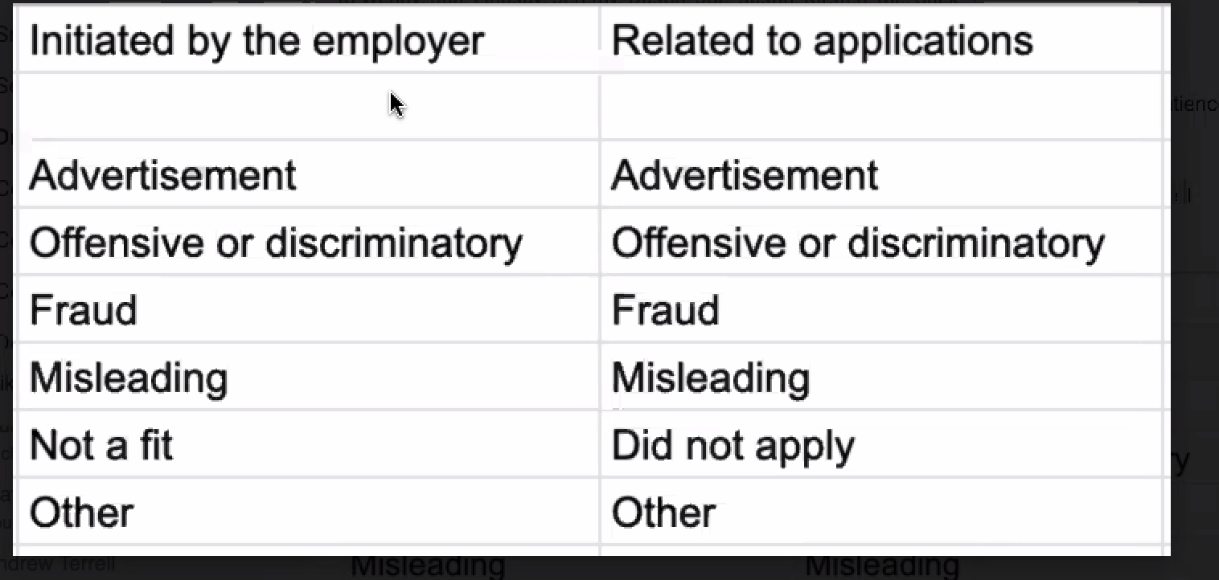

No Sub Categories - Creates challenges
- 2 clicks - do not want two layers,
- multiple layers - additional complexity - user will not go through second layer

NOTE - Maitreyi (NPS team meeting) - focused on getting away form free text to secondary definitions, can leave comment.

Email templates - current reporting issues
- How the link is inserted into email template (false negatives) because is hidden
- List of options job seeker is confusing - overlap and not distinction -
  - Not precise enough in collecting data - list of options not distinct
- Option for additional information - “Other” - noise - not usable
- Unable to tailor to products

Notes/Issues
- Report a Conversation did not exist when Report a Message was primary concern
- Jano and Beatrix email thread was only for Report a Conversation platform. - This is looking ahead to report a conversation
  - Final Doc for all Report a Message
- Many more messages floating around the relay
- Buckets will change for type of message
- REPORT REQUIREMENT - DREMR ecosystem definition - to build list of reporting option
  - Risk & Quality Ops to look at indexes and create first attempt at identifying all email templates
- HIRE I2A emails & campaigns are sent through secondary relay, Not DREMR or Raven - all emails sent through POST (Graham validated with Deniz & Timothy)
- SMB I2A - Raven relay

Decisions & Action Items

- DREMR - 90% covered with “shotgun approach” for Report a Conversation
- Content Capture - NO Secondary buckets
  - “Tell us more” - ONLY
- Initial buckets - “Other” + free text option to provide additional context in first
  - Always visible
- Indeed targeting activities, e.g., Hire I2A and SMB I2A email content and Display ad content visible on Indeed’s platform - Incorporating Job Seeker/user reporting on content associated with

  - Targeting Products:
    - There is a distinction between Dremr messages for Employers <> Job Seekers and
    - Raven messages primarily Indeed > Job Seeker.
    - I2A emails are Indeed targeting products.
      - We do not provide a two-way dialogue for Job Seekers directly with the employer; however, the employers draft Job Content. Targeting Products also include ITA Apply, ITA Brand and similar to ITA Brand, more types of Display advertising that the Enterprise Org is in the process of developing. Each product consists of logic to identify whether or not to provide Job Seekers visibility to the advertised/displayed content.
    - Hire I2A, and SMB I2A emails include a single job description targeted at Job Seekers. We will need to give Job Seekers the ability to report based on the Job content as well as the relevance of the targeting.
      - For example, if a Job Seeker that included Dominos Pizza on their Resume but worked in an IT department receives a job description for a delivery person at a Pizza Parlor. We want to ensure Job Seekers can report the irrelevant email as it relates to their experience in IT. Similarly, if the Pizza Parlor is advertising using a Display product on Indeed's platform, we want the Job Seeker to have an ability to report the content as well as the relevance of it to their search/experience.

