JIRA Migration Recommendation

List of Projects in Boston to be migrated

BDT
CHET
DKB
DM
EST
FR
PROD

Cloud A - PB - Projects
Cloud B - BL - Projects

Three approaches to merge multiple instances of Jira cloud are:
- Merge multiple sites in Jira Server (Recommend - Merge two Cloud backups of select “Projects” into Server, then migrate - Easier to UAT)
- Import to Jira Server and use the Jira Cloud Migration Assistant (“issues” - only)
- Import issues using CSV, Move attachments (Ugly)

Supporting documentation - How to merge two JIRA Cloud instances
JRACLOUD-72570 - Support for Single Project Imports between Cloud Sites
JRACLOUD-34307 - Allow Single Project Export
JRACLOUD-60916 - Import / Export (backup) individual projects

Contact Support in Advance (for dedicated resource allocation)

Support Contact Form - Include the following information

- what stage in your migration you're at
- which products you plan on migrating
- which direction you're migrating to and from
- any merging or consolidation you'll need to do
- how many users you need to migrate
- your overall timeline

Recommended Solution: Merge multiple sites in Jira Server

This approach is to use a temporary Jira Server application, which allows you to import specific projects. Using this method you can combine entire sites, or import only particular projects from one Jira Cloud site to another.

If you choose this method you'll need to take Jira backups from all your Jira Cloud sites, merge them through a temporary Jira Server application, and then import them back to your final cloud site.

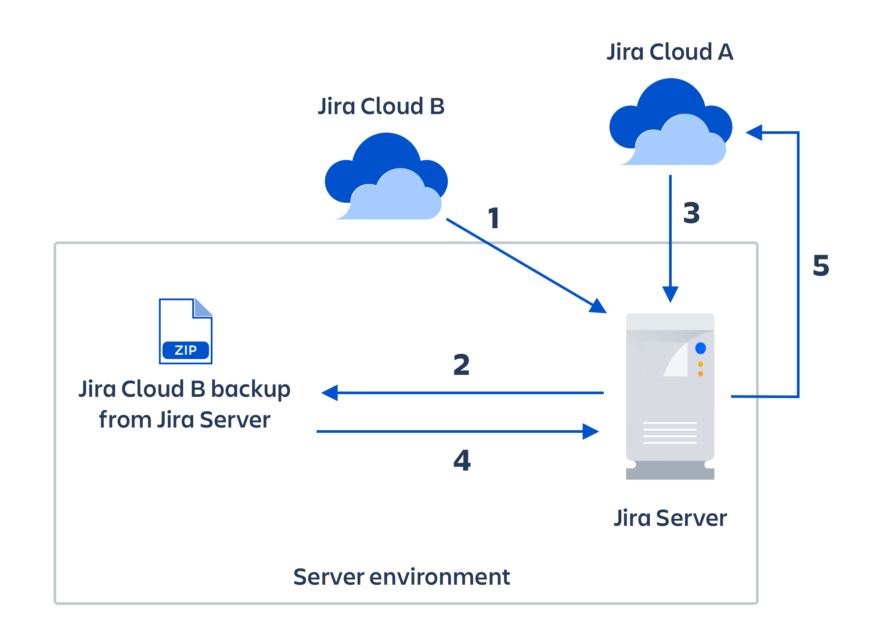

How to use this approach

You have two Jira Cloud sites: Jira Cloud A and Jira Cloud B. You want to move all or some projects from Jira Cloud B into Jira Cloud A so you have a single, consolidated cloud site. The basic outline of this process is:

Install the latest version of Jira Server. You can do this using a free evaluation license.

Create a backup for Jira Cloud B. This will contain the projects you'd like to import to Jira Cloud A.

Next, import your data from Jira Cloud B to Jira Server.

Create an XML backup of Jira Server. This will be used later for project imports.

Create a backup for Jira Cloud A

Import the backup for Jira Cloud A to Jira Server.

Using the Jira Server backup you created in step 4, import the projects you want from Jira Cloud B to Jira Server. You should now have the projects you want from both Jira Cloud A and Jira Cloud B in Jira Server.
If the attachments are not included during the project restore, the imported project will not have attachments associated with it. Attachments can't be restored separately because the database entries for the attachments will be missing.

After successfully importing all the required projects, create a backup of Jira Server.

Import that backup file into your final Jira Cloud site.

Limits to this approach

App data and users will not be migrated.

Requires knowledge of how to install and set up a server application.

Merging sites usually takes quite some time to complete, especially for large sites.

We strongly encourage performing a dry-run of the import and doing User Acceptance Testing on a test cloud site (which can be created using a free trial) before proceeding with the import on your production cloud site. This way, you can anticipate the issues that you may encounter during migration and resolve them in advance.

Migration Wizard for “Issues”: Import to Jira Server and use the Jira Cloud Migration Assistant
Two Jira Cloud sites: Jira Cloud A and Jira Cloud B. You want to move all or some issues from Jira Cloud B into Jira Cloud A (your target site) so you have a single, consolidated cloud site. To complete this process you’ll need to:
Set up a Jira Server site, import a backup your cloud data from your first site, and then use the Jira Cloud Migration Assistant to move your data into the target cloud site. This is the simplest approach to maintain your setup and configuration and only requires downtime for one of your cloud sites.
    - Install the latest version of Jira Server. You can do this using a free evaluation license.
    - Create a backup for Jira Cloud B. This will contain the users and projects you'd like to import to Jira Cloud A.
    - Next, import your data from Jira Cloud B to Jira Server.
    - Use the Jira Cloud Migration Assistant to move and merge your projects from Jira Server into Jira Cloud A

Limits to this approach
- App data will not be migrated.
- Jira Service Desk is not supported.
- Some fields or configuration may not be supported. Check the list of what is migrated with the Jira Cloud Migration Assistant before choosing this method.
- Requires knowledge of how to install and set up a server application.
- We strongly encourage performing a dry-run of the import and doing User Acceptance Testing on a test cloud site (which can be created using a free trial) before proceeding with the import on your production cloud site.

Not Recommended: Import issues through CSV
Two Jira Cloud sites: Jira Cloud A and Jira Cloud B. You want to move all or some issues from Jira Cloud B into Jira Cloud A so you have a single, consolidated cloud site. The basic outline of this process is:
- Search for all the issues in the required project(s) in Jira Cloud B, and export them as CSV.
- Create the projects as empty in your Jira Cloud A site.
- Import the CSV file to the project(s) in your Jira Cloud A site.
- To migrate attachments as well, you'll need to follow additional steps.

Limits to this approach
- App data and users will not be migrated.
- Before importing the CSV file, you'll need to recreate the project and set up the project's configurations on the target site, including Workflow, Permission Schemes, etc. This manual configuration may take some time.
- This approach only merges issues, not entire projects.
- Issue History will not be retained – for example, timestamp of issue transitioned or issue updated.
- You'll need to follow additional steps to import attachments.
- Links to Confluence pages under the "Mentioned On" section in Jira issues will not be imported. We have an open feature request where you can learn more or vote for this issue to be resolved.

General Concerns:

- Users & App data do not migrate - must be named exactly the same in new system
- Boards & Filter preservation (Individual Dashboards?)
- JIRA Service Desk? (does not migrate with migration assistantnogo)
- Attachment directory & naming
- (http://confluence.atlassian.com/display/JIRA/Restoring+Data) imports,
  - Support for for "Single Project" http://confluence.atlassian.com/display/JIRA/Restoring+a+Project+from+Backup imports is also required.

